APPLICATION SHEET
to participate in
International Film and Video Arts Festival
for a new non-violent culture of peace

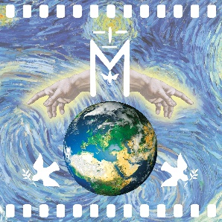

The contest is open from June 6 to August 6, 2023
Only one film or video can be entered
for which the following fields must be filled in:

Name and surname of the author:

Place of living:

Country:

E-mail:

Birth Year:

Movie Name:

Movie content (300 characters with spaces):

Genre:

Length of the film (minimum 1 maximum 3 minutes):

